C:\Users\RYE\Desktop\CCJE LOGO2.tifRepublic of the Philippines

**OCCIDENTAL MINDORO STATE COLLEGE**

Labangan, San Jose, Occidental Mindoro

Website: www.omsc.edu.ph Email address: omsc_9747@yahoo.com

Tele/Fax: (043) 491-1460

**College of Criminal Justice Education**

**ON THE JOB TRAINING**

**ACCOMPLISHMENT REPORT**

**Agency: Highway Patrol Group Date: January 28,2025**

**Address: Camp Winston Sibley Ebersol, Barangay Duration: January 20-24,2025**

**San Roque1, San Jose Occidental Time: 1:00-5:00 pm**

**Year/Section: BS ISM 4G**

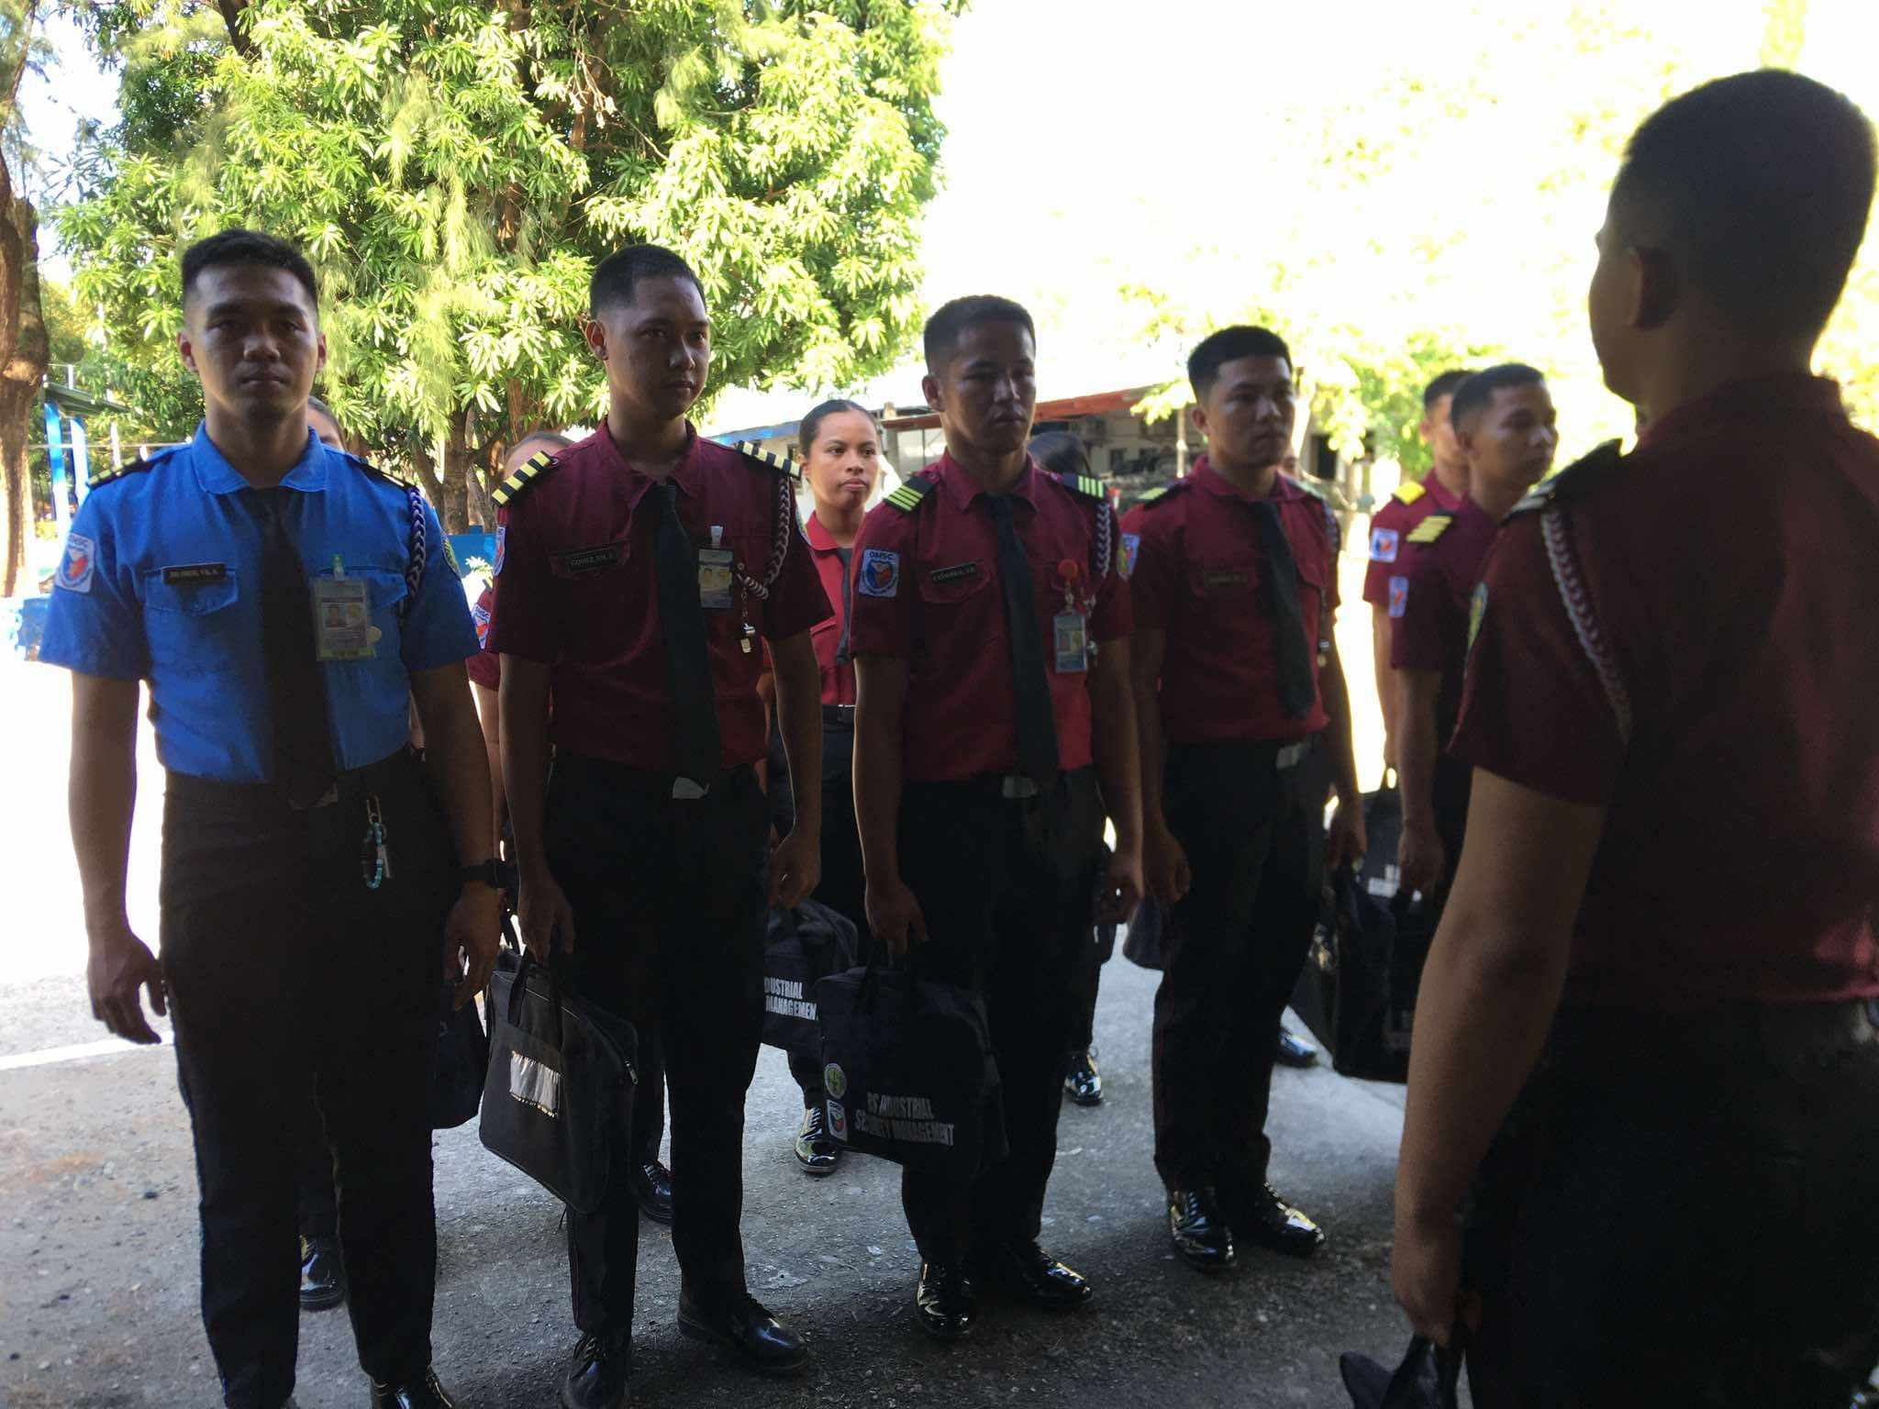

j 

January 21,2025,We had an in-depth disciussion and question and answer about the fundamental knowledge about the Highway Patrol Group.

January 20,2025, First day of deployment of the CCJE Highway Patrol Group

C:\Users\RYE\Desktop\CCJE LOGO2.tifRepublic of the Philippines

**OCCIDENTAL MINDORO STATE COLLEGE**

Labangan, San Jose, Occidental Mindoro

Website: www.omsc.edu.ph Email address: omsc_9747@yahoo.com

Tele/Fax: (043) 491-1460

**College of Criminal Justice Education**

**ON THE JOB TRAINING**

**ACCOMPLISHMENT REPORT**

g 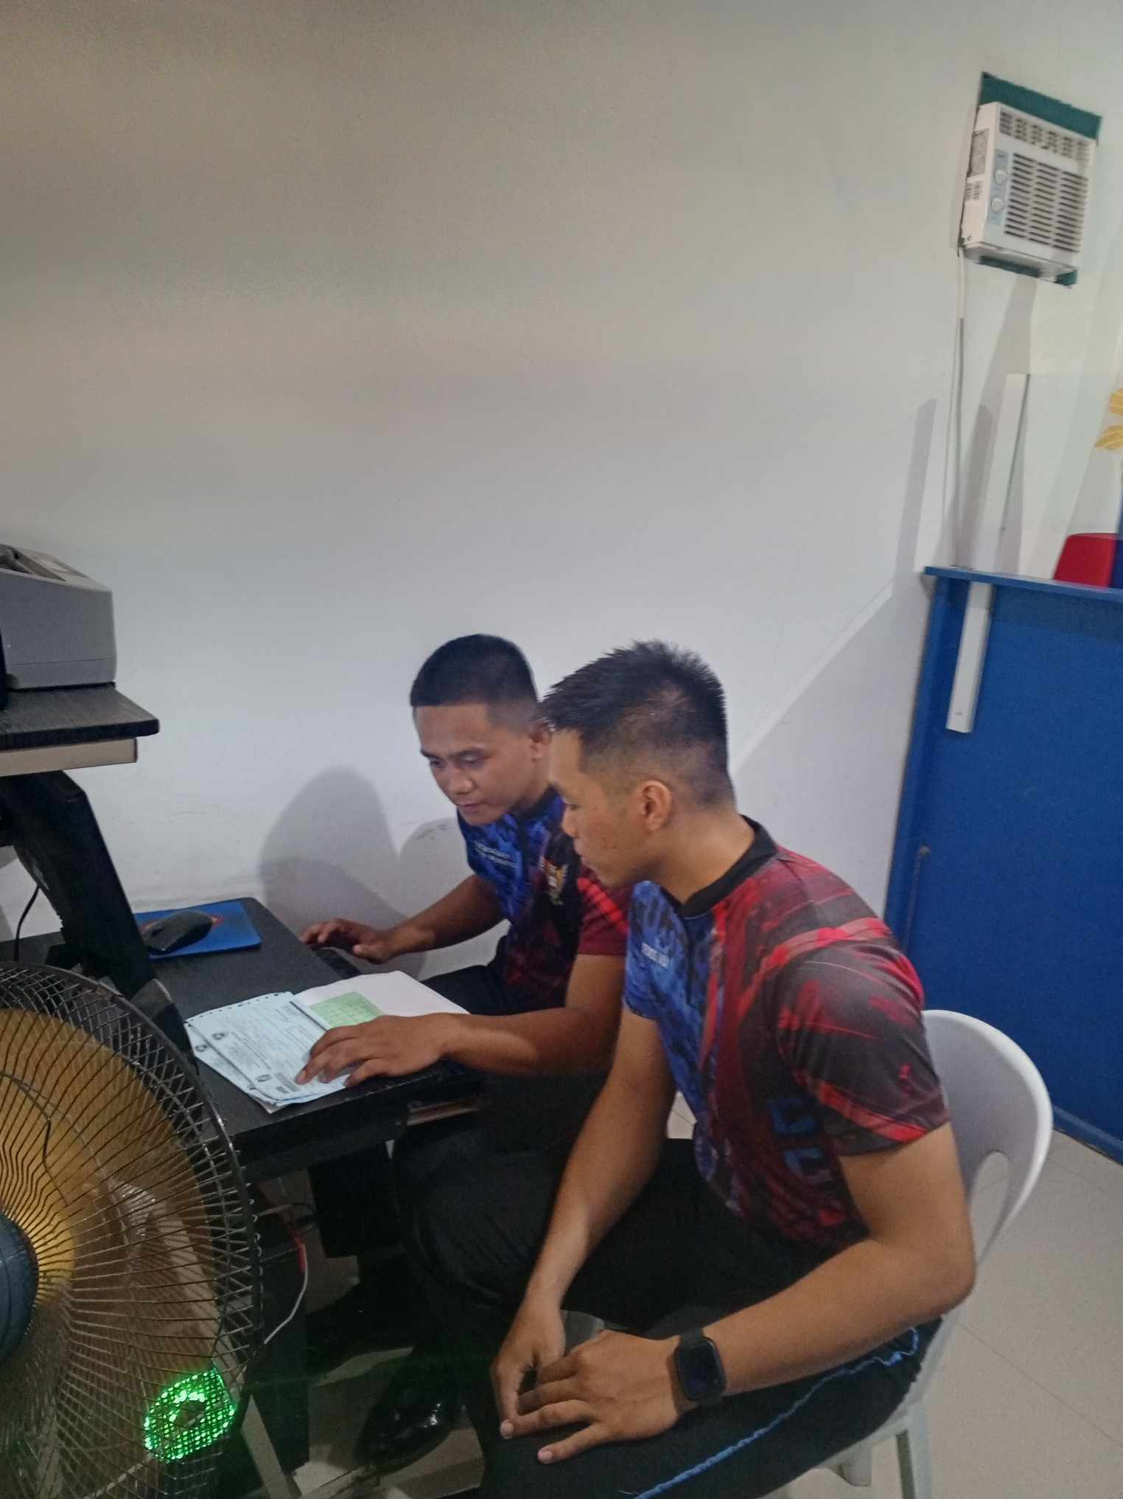

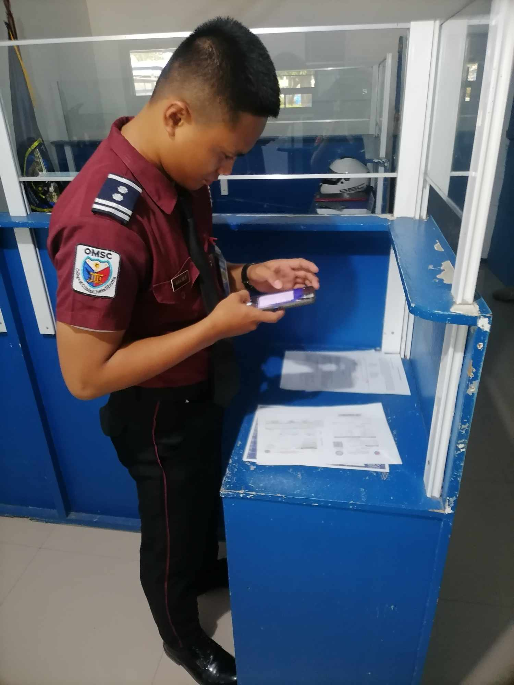 h

January 23,2025, Encoding the important details of vehicles papers.

January 22,2025,Scanning the important papers of vehicles clearances.

**.**

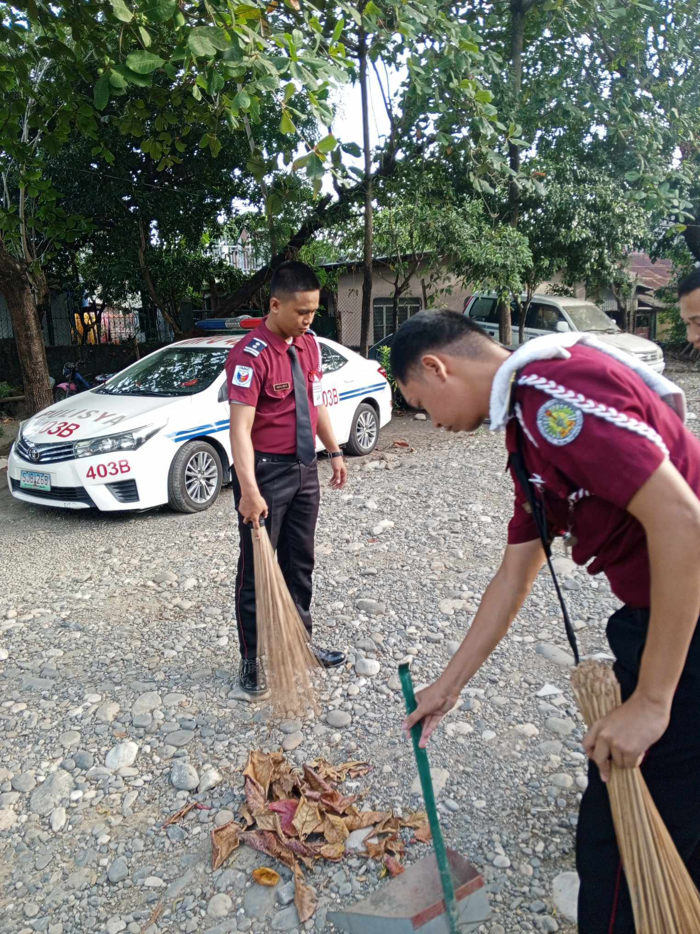 n

January 24,2025, Part of our OJT purposes is to clean the surroundings,so that we can give a calm impression and a fresh green clean area.

**Prepared by:**

**Noted by:**

**ARVIN RYAN P. ALGA**

**OJT Trainee OJT Supervisor**